Assisted Practice 23 Name: Prajwal Diwakar

Pre and Post Processors.

Pre Processors:

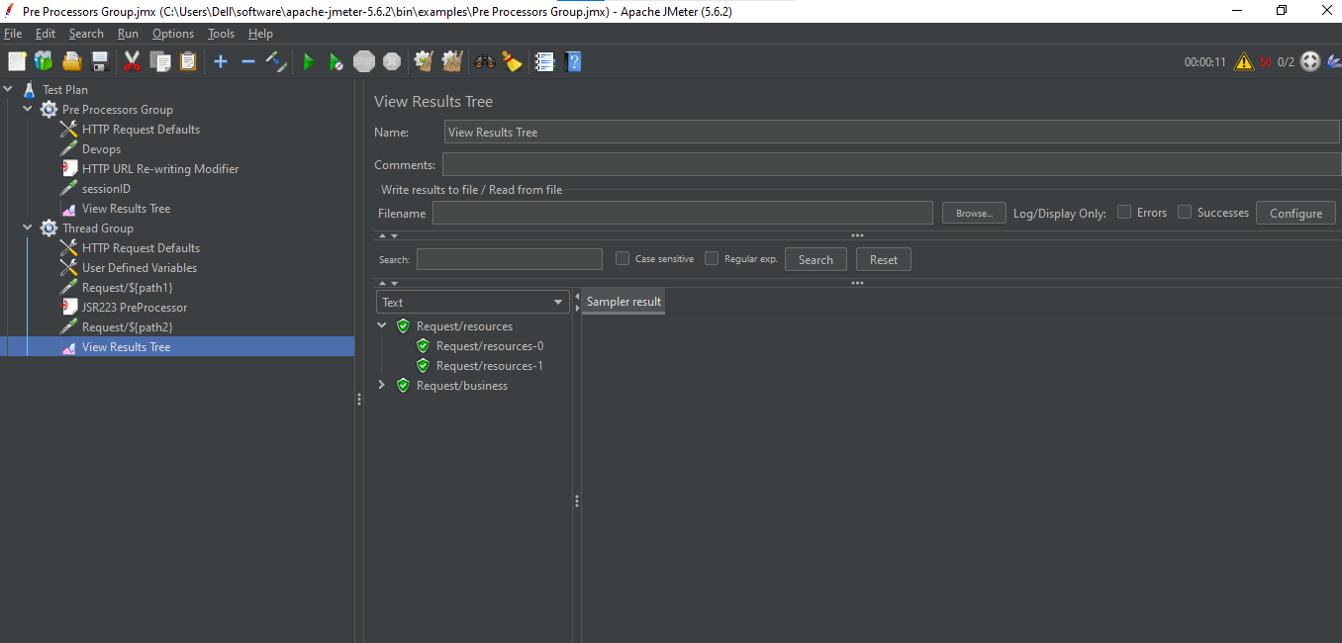

Post Processors:

